Week 14-15

Project title: | Apple Stock Price hover box
Topic: | Extending The Apps
What progress have you made this topic?
In the Apple Stock price visualization, I added a dialog box that displays information about a trading day.
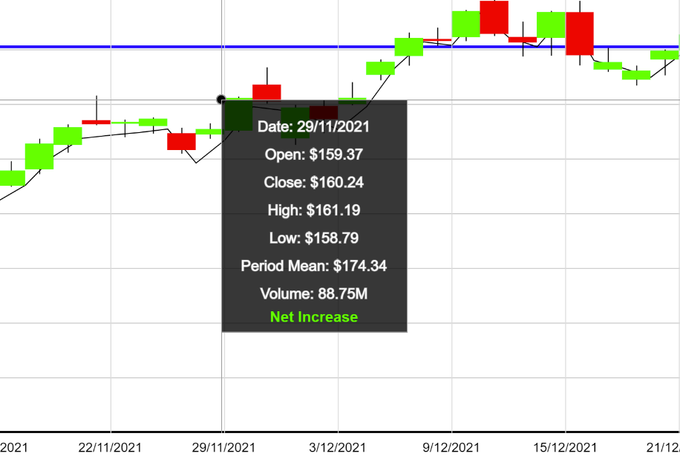
(Box displaying trading day information)

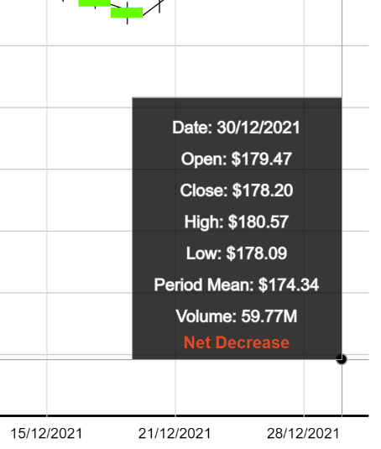
(Box flipping both horizontally and vertically as cursor approaches Axis edges)

What problems have you faced and were you able to solve them?
A problem I encountered with implementing the dialog box, is the date being displayed on the box not matching the date on the x-axis. For instance, the box might say 6th December, while the x-axis might say 3rd December.

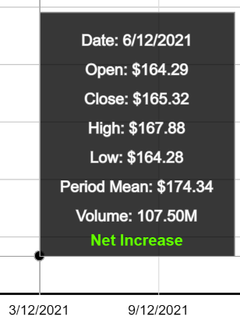
(Date Mismatch on x-axis and box)

I worked around this issue by reworking the code responsible for calculating the boxes’ dates. Initially the date was being calculated by dividing the distance between the mouse’s x position and the left margin by the candlestick box width. Since this number was a floating-point value, I was using a round of this value. The issue was resolved by using the ceiling of this value instead.

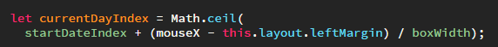
(Changes made to day index function to incorporate ceiling)

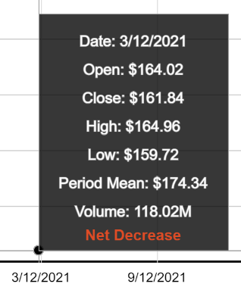
(The date in the box matching the x-axis after the changes)

What are you planning to do over the next few weeks?
I plan to start working on the hours of daylight visualization. Secondly, I plan to simplify the existing code for the other visualizations.
Are you on target to successfully complete your project? If you aren’t on target, how will you address the issue?
At my current rate of progress, I am on track to completing my project in time.

Week 16-17

Project title: | Daylight hours
Topic: | Extending The Apps
What progress have you made this topic?
In these two weeks, I added the daylight hours extension. This extension displays the hours of daylight at every latitude for every day of the year. Furthermore, I added a play/pause button that increases the day of the year automatically.

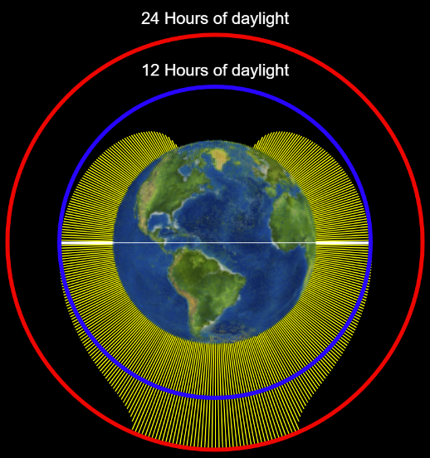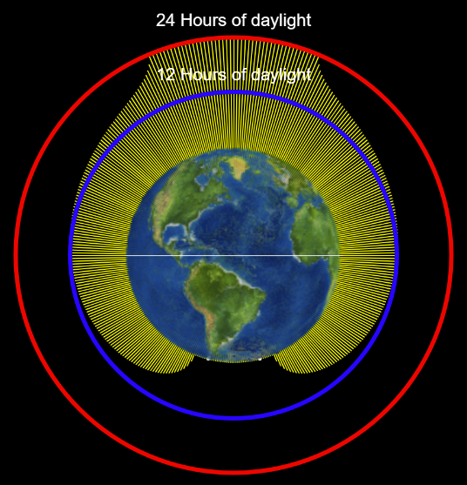
(Hours of daylight extension)

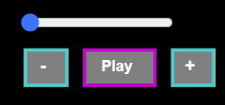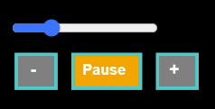
(Visualization paused on the left and playing on the right)

For the creation of the buttons, I devised a constructor function. To detect if the user’s mouse is over the button’s coordinates, I devised a function called over. Using the mouse pressed function, the play pause values could be toggled by the visualization.

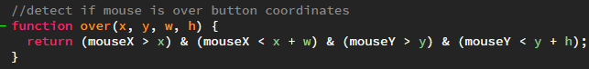
(Mouse Over detects if mouse is within bounds of the button object)

What problems have you faced and were you able to solve them?
The mouse pressed function could not determine whether the play or pause had been clicked on hence the autoloop feature was not working.

The mouse pressed function can only be declared outside the main visualization and button constructor functions. Hence the mouse pressed could not access the button objects. To fix the issue, the buttons had to be made global variables. This was done by pushing the button objects into a global array. Within mouse pressed, a for loop loops over all button objects and changes their toggle values.

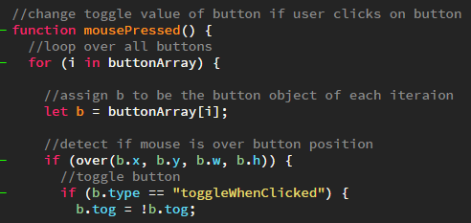
(This code loops over all button objects and changes button toggle Boolean if clicked)

What are you planning to do over the next few weeks?
I plan to start system and usability testing and plan to complete the heat map visualization.
Are you on target to successfully complete your project? If you aren’t on target, how will you address the issue?
At my current rate of progress, I am on track to completing my project in time.

Week 18-19

Project title: | Heat Map
Topic: | Extending The Apps
What progress have you made this topic?
My plan was to make a heat map that displayed population, population density and per-capita income. I started by creating a mockup of the legend box in the p5.js web editor. Next, I devised an if statement that determines the fill value of a country based on the value passed to it.

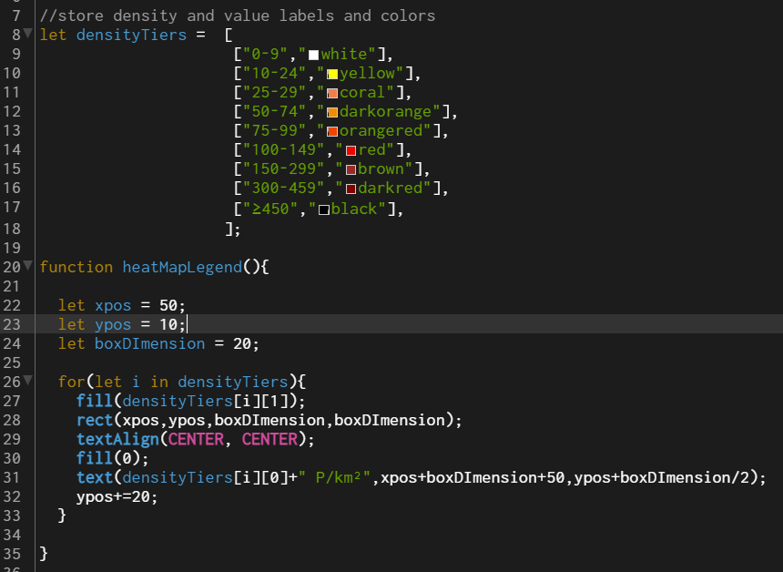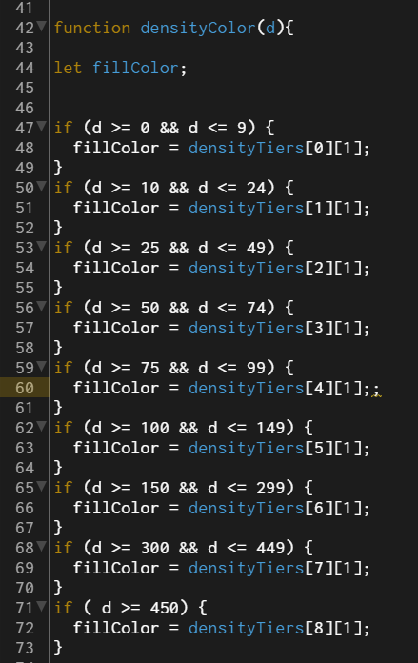
(Legend box colors and fill color if statement)

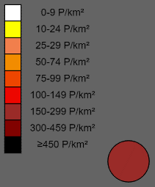
(Legend box in p5.js web editor. The circle is filled in accordance to the color tier of the value passed to it)

Next, I found an existing code base for drawing the world map. I integrated this code with my CSV and if statements to fill every country with its respective population density color.

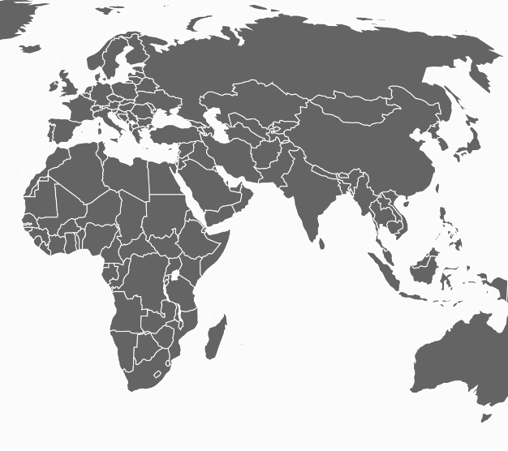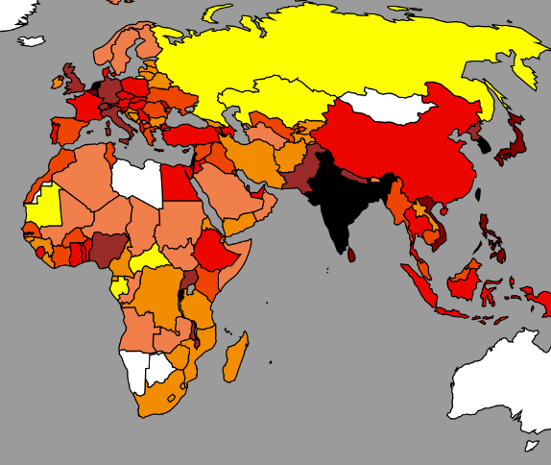
(Left image displays initial colors, right image displays countries by population density)

What problem have you faced and were you able to solve them?
I had trouble making the code for the heat map modular. I initially experimented with having the code in the main visualization file. However, I soon realized that this code lacked modularity. I hence decided to create a separate constructor function.

Moving the script to another page resulted in a lot of bugs. These bugs took longer to work through than initially expected. Eventually, I managed to work through these bugs.

What are you planning to do over the next few weeks?
I plan to start system and usability testing.
Are you on target to successfully complete your project? If you aren’t on target, how will you address the issue?
The heat map visualizations took longer to complete than initially expected. I plan to meet the deadline by prioritizing this project over other commitments.

Week 20-21

Project title: | Testing
Topic: | Testing with Users
What progress have you made this topic?
System Testing

Through system testing, I uncovered tests that the program failed. An example of a failed test was the mouse over functions failing when switching between visualizations. This was happening due to array memory not being cleared between visualization switches. This bug was promptly fixed for subsequent tests.

What problem have you faced and were you able to solve them?
Usability tests using the think aloud protocol, showed that users were often unable to make sense of the population pyramid visualization. When comparing the population pyramids of two countries, users could not determine the country with the older population.
For subsequent tests, a dialog box was added that displayed the percentage of each population over the age of 50. This made it more obvious for the users in subsequent tests.
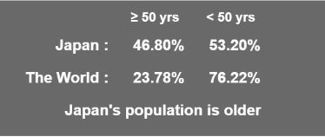
(Box displaying the country with the older population)

What are you planning to do over the next few weeks?
I plan to incorporate the feedback of my users into my submission. I also plan on making my code more readable
Are you on target to successfully complete your project? If you aren’t on target, how will you address the issue?
Presently I am slightly behind my schedule. I plan to address the issue by prioritizing this project over other commitments.

